4. Write a Pandas program to create a line plot of the historical stock

prices ofAlphabet Inc. between two specific dates.

Code:

import pandas as pd

import matplotlib.pyplot as plt

# Sample stock price data

data = {

'Date': ['2024-01-01', '2024-01-02', '2024-01-03',

'2024-01-04', '2024-01-05'],

'Close_Price': [140, 142, 141, 145, 148]

}

# Create DataFrame

df = pd.DataFrame(data)

# Convert Date column to datetime

df['Date'] = pd.to_datetime(df['Date'])

# Create Line Plot

plt.figure(figsize=(8,5))

plt.plot(df['Date'], df['Close_Price'], marker='o')

plt.title('Alphabet Inc. Stock Prices')

plt.xlabel('Date')

plt.ylabel('Closing Price ($)')

plt.grid(True)

plt.show()

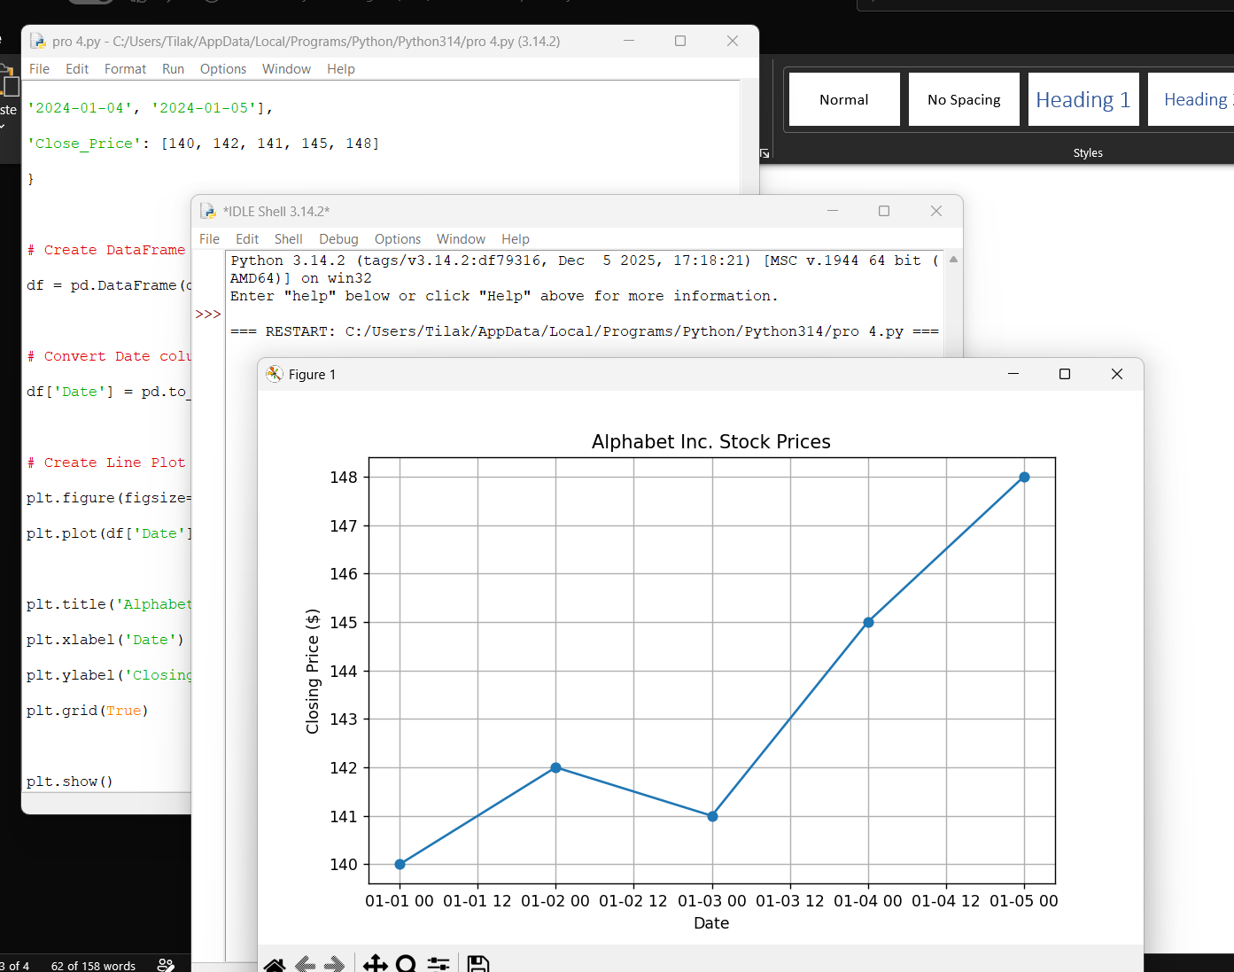Output:

5. Write a Pandas program to create a bar plot of the trading volume of

Alphabet Inc. stock between two specific dates.

Code:

import pandas as pd

import matplotlib.pyplot as plt

# Sample trading volume data

data = {

'Date': ['2024-01-01', '2024-01-02', '2024-01-03',

'2024-01-04', '2024-01-05'],

'Volume': [1200000, 1500000, 1300000, 1700000, 1600000]

}

# Create DataFrame

df = pd.DataFrame(data)

# Create Bar Plot

plt.figure(figsize=(8,5))

plt.bar(df['Date'], df['Volume'])

plt.title('Alphabet Inc. Trading Volume')

plt.xlabel('Date')

plt.ylabel('Volume')

plt.show()

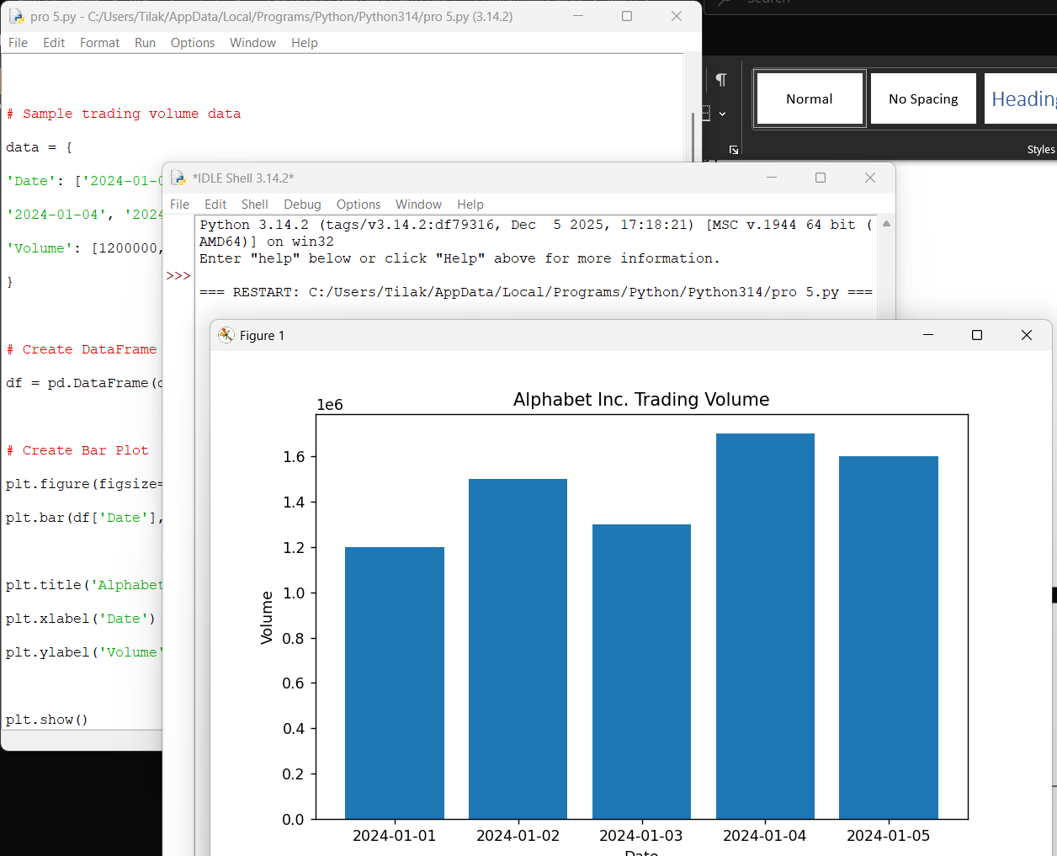Output:

